# Student Assessment Survey Analysis

# Level 1 Assessment:

* Two schools were involved in the assessment I.e Kongoni primary school (95 students) and St. Joseph primary school (52 students).
* A total of 147 students participarted in the assessment, 69 males and 78 females from the two schools as shown in the table below.

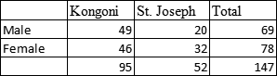

***General performance by Gender and School***

* Pupils from St. Josephs primary school perfomed better generally than pupilsfrom kongoni primary school pupils.
* The general performance of females in the two schools is also observed to be better than their male counterparts.

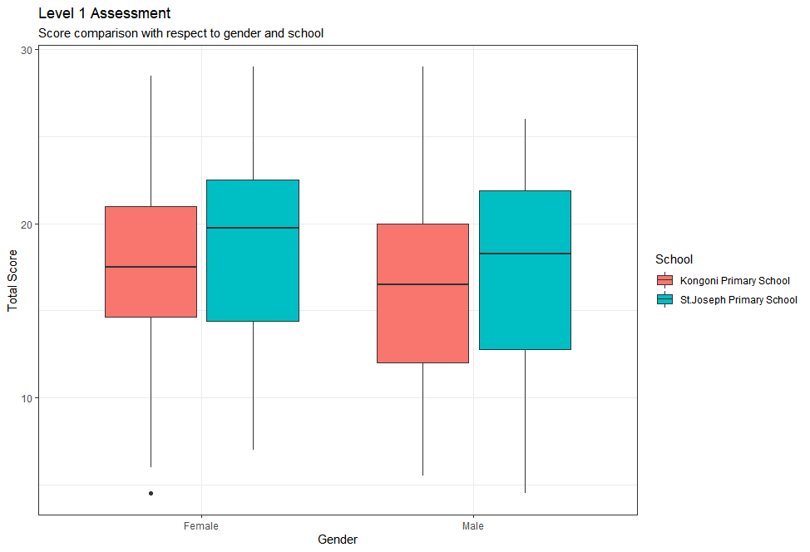 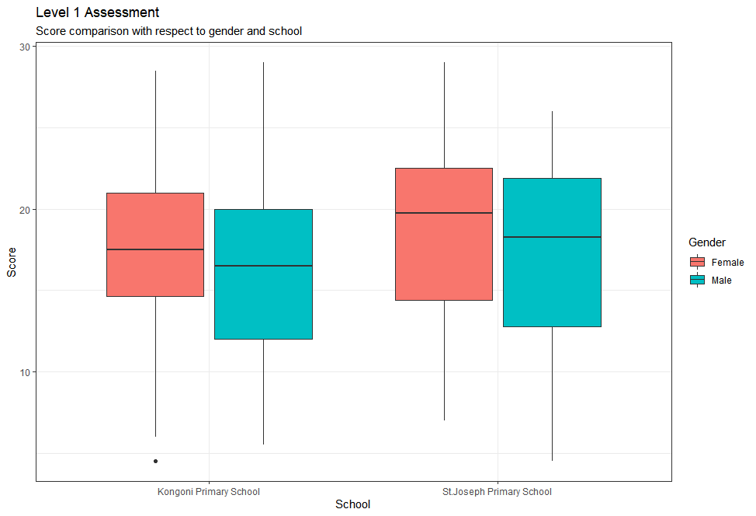

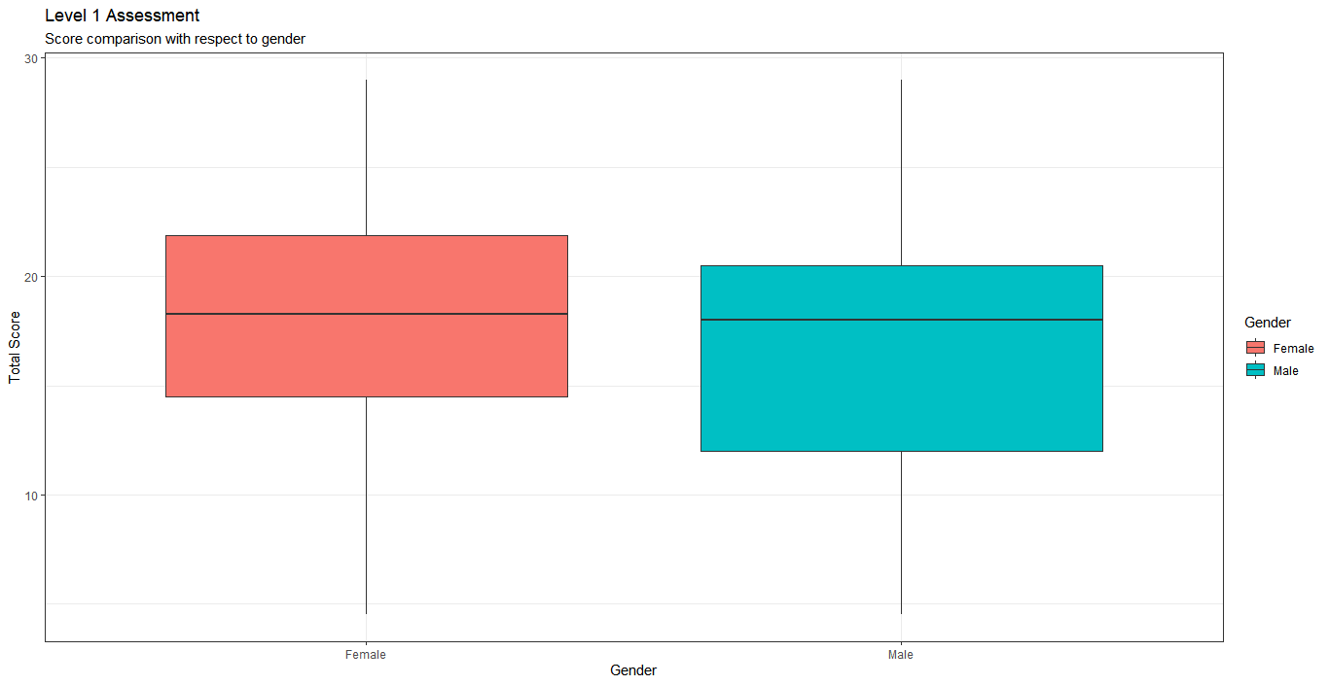 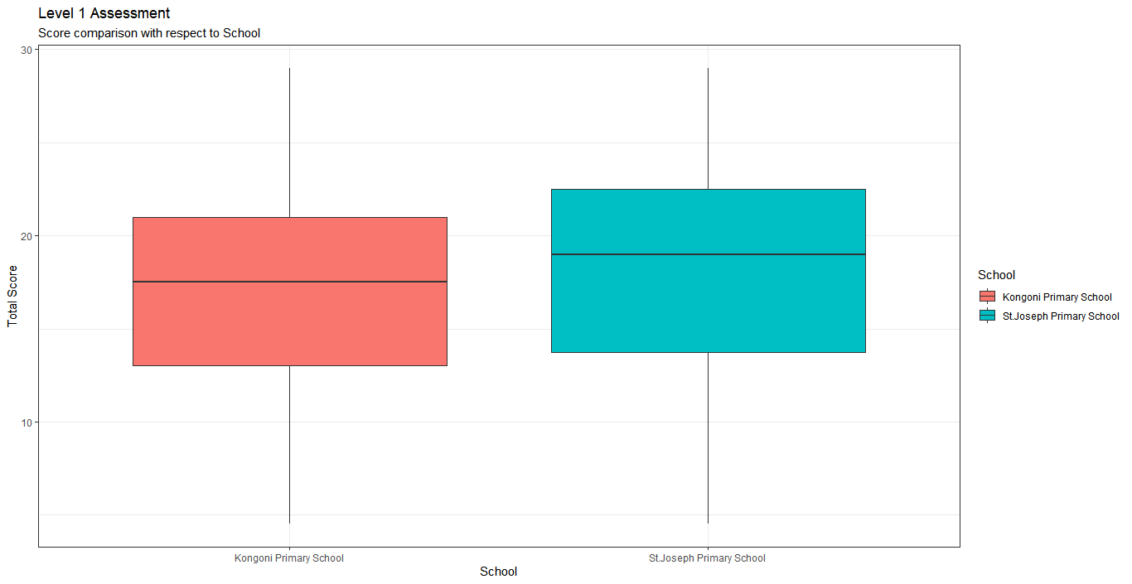

***Maths perfomance***

* There is slight difference in maths performance by gender but females have a better performance than male.
* Kongoni school doing better in maths on average than St. Josephs

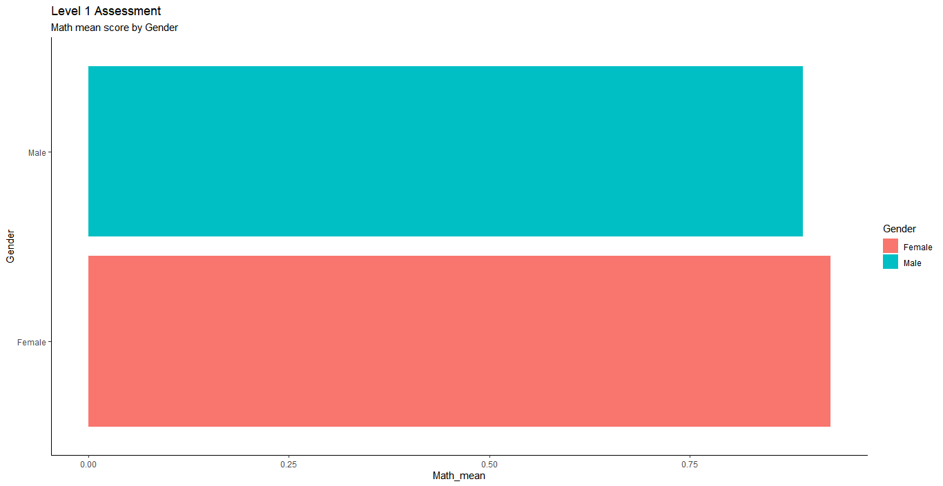 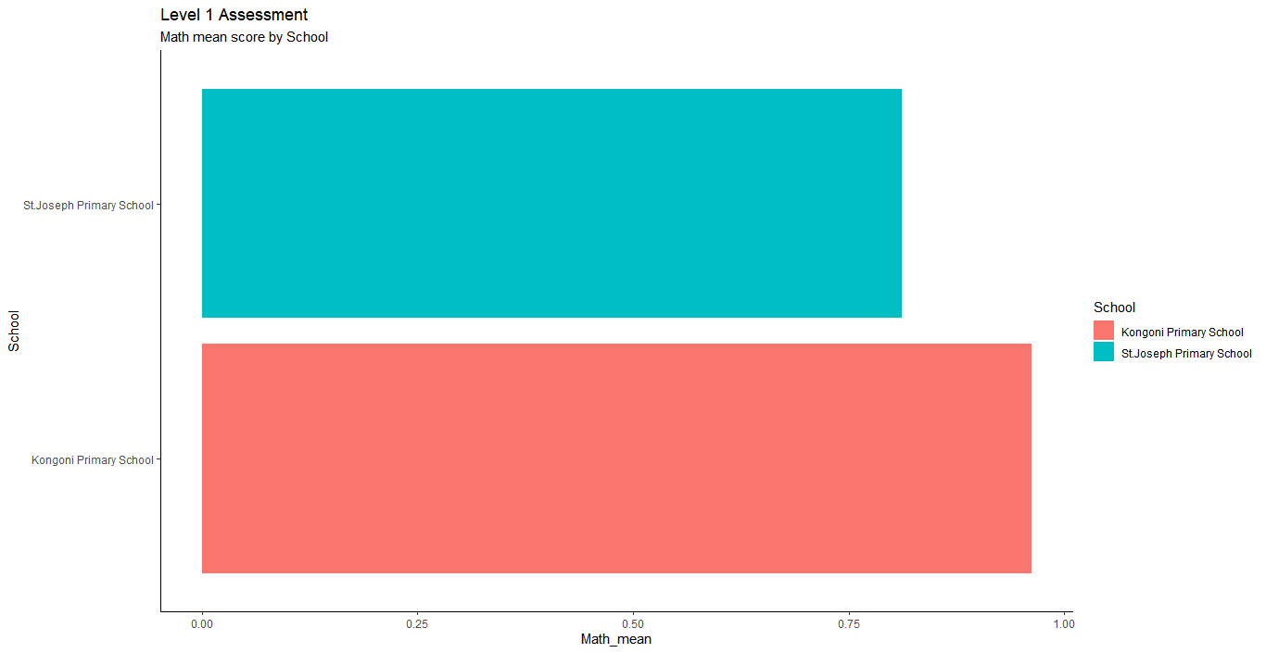

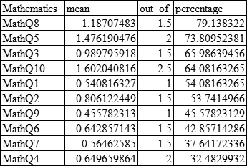

*Student perfomance on each maths questions. MathQ8 being highly performed and MathQ4 being the least performed.*

***Science performance***

* Females doing better than males in science.
* St. Joseph performing highly better than Kongoni in Science.

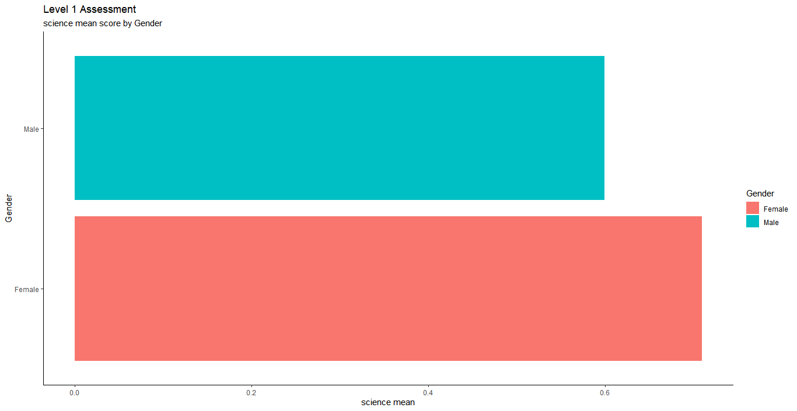 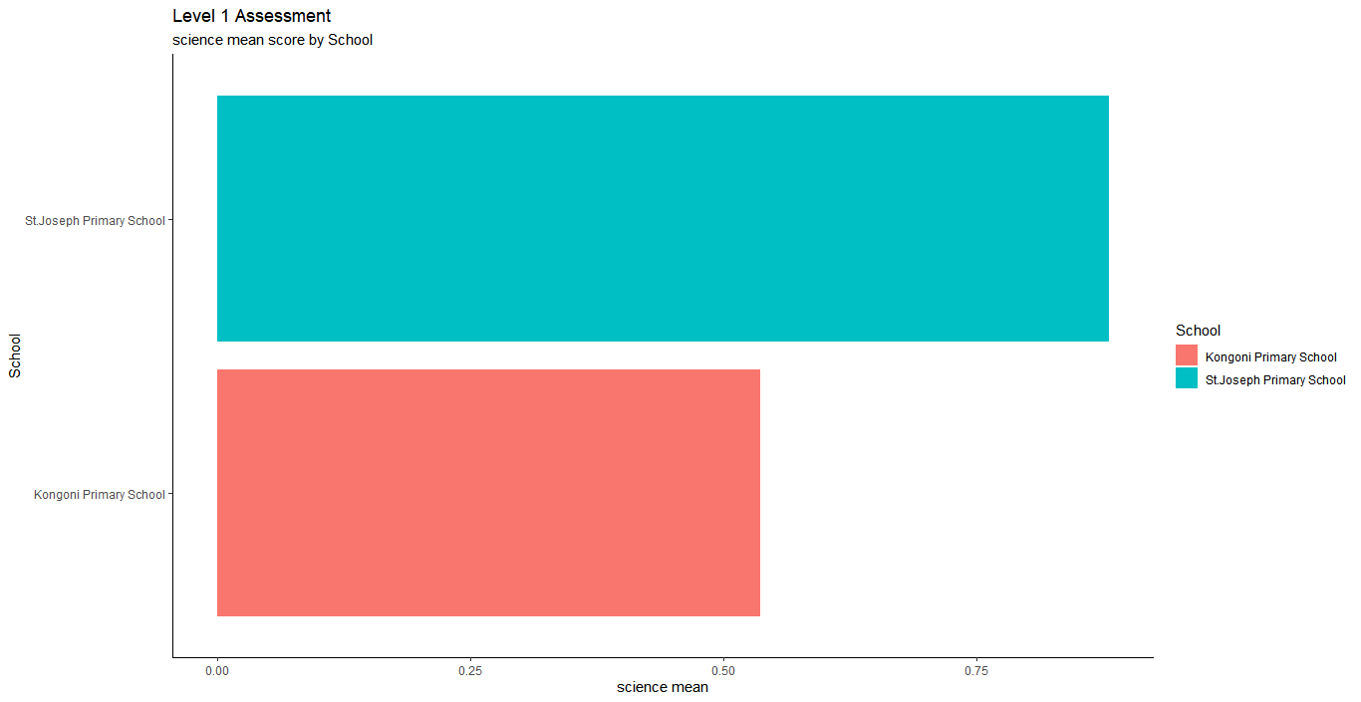

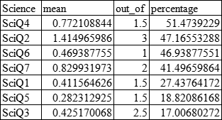

*Student perfomance on each Science questions. SciQ4 being highly performed and SciQ3 being the least performed.*

Generally, the students perfomerd purely in science compared to maths.

***Literacy performance***

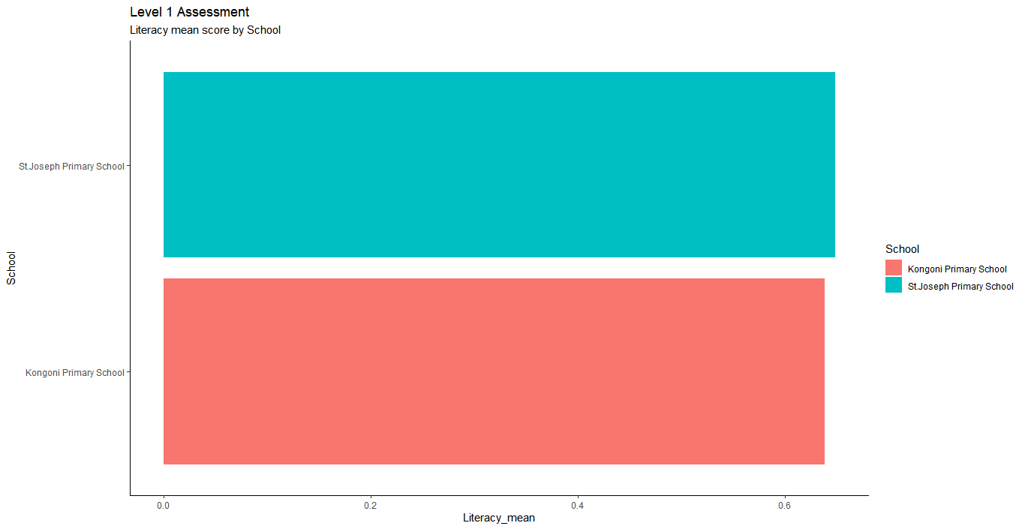 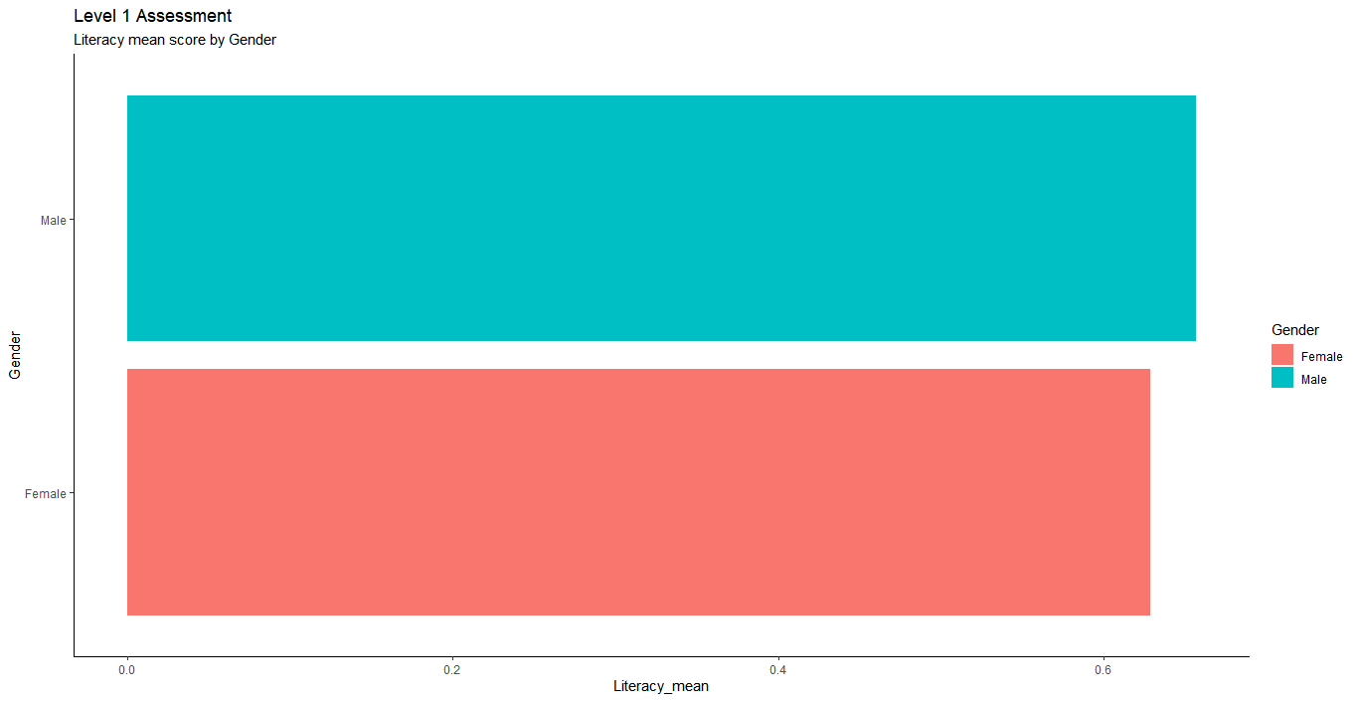

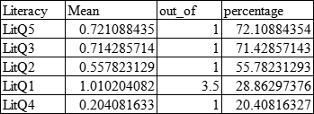

*Student perfomance on each Literacy questions. LitQ5 being highly performed and LitQ4 being the least performed.*

***Skills performance***

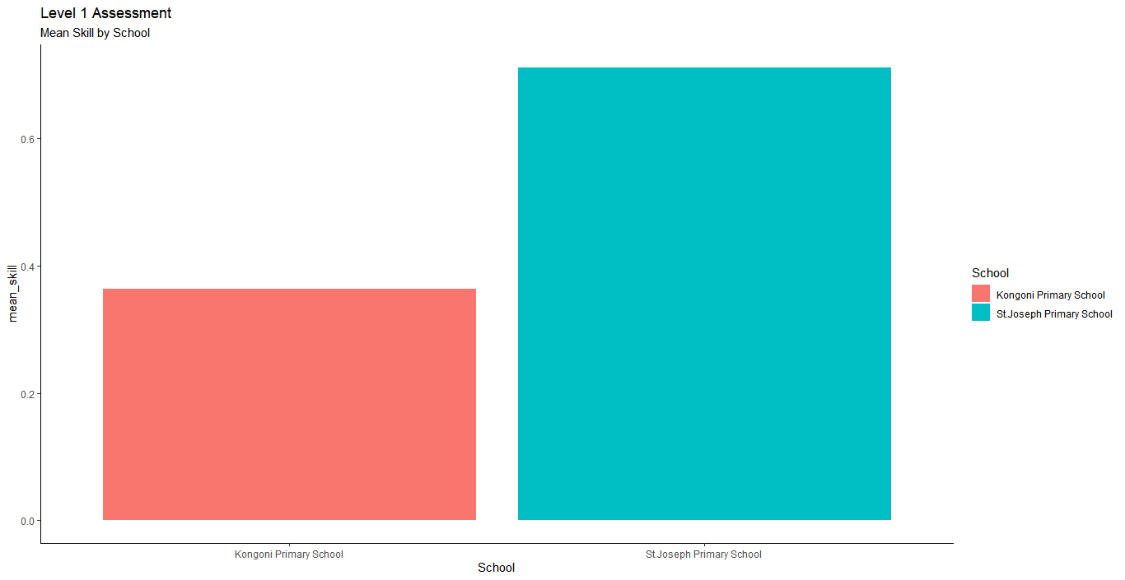 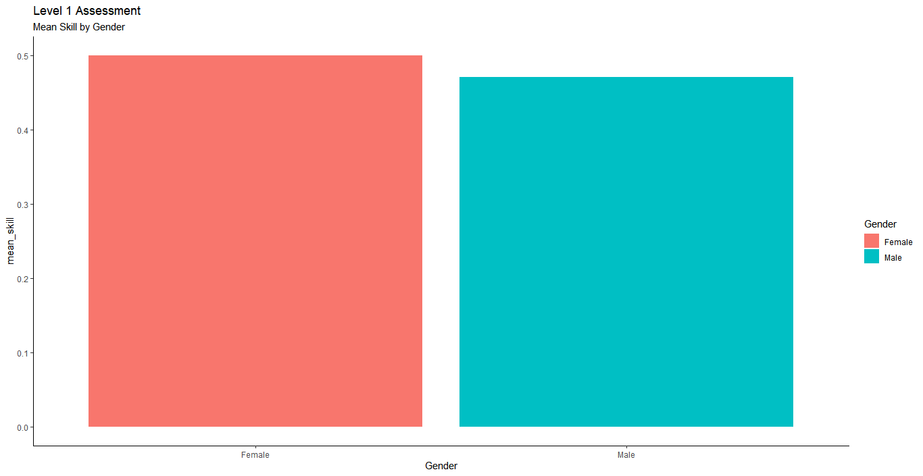

**Level 2 Assessment:**

* The assessesment was done among two schools, St. Joseph Primary(72 pupils) and Kongoni Primary(112 pupils)
* It was done by a total of 184 pupils with 94 being females and 90 males.

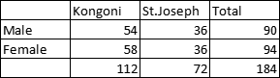

***General Performance***

* There is a slight difference in total performance across the two gender groups.
* The mean score for males in both schools is almost the same though the variation is bigger in St. Josephs.
* Female performance is still higher than that of males in both schools.

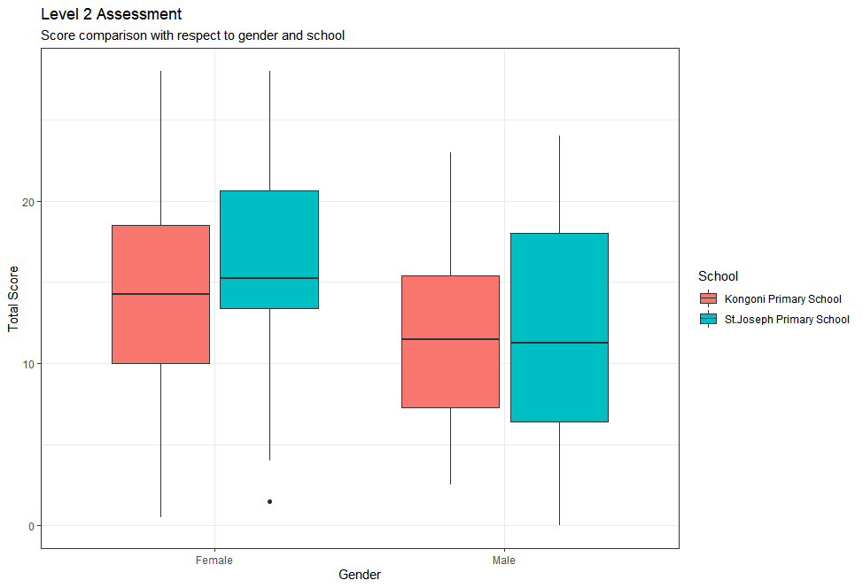 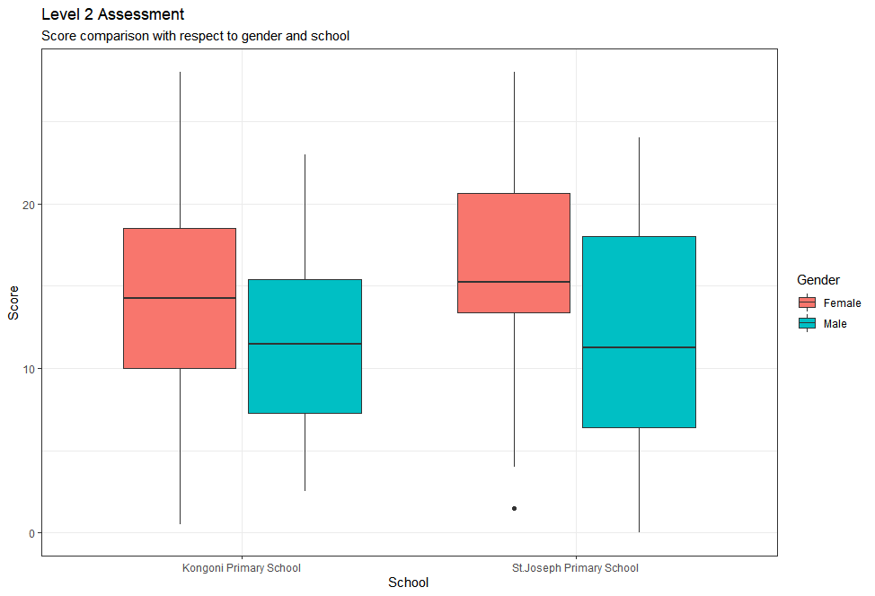

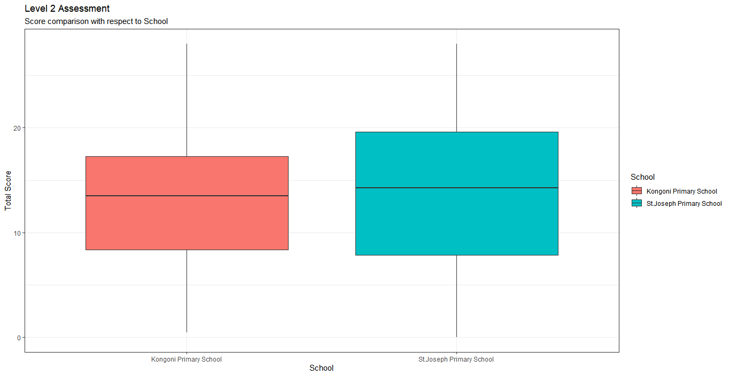 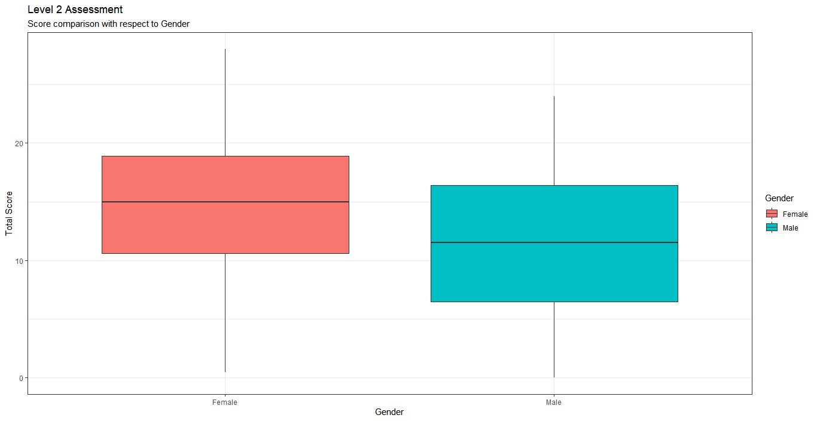

***Maths performance***

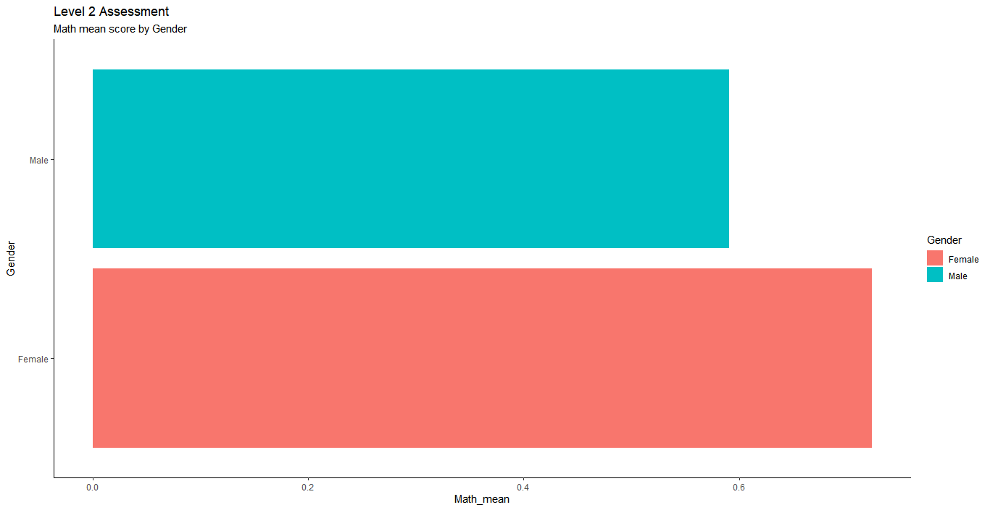 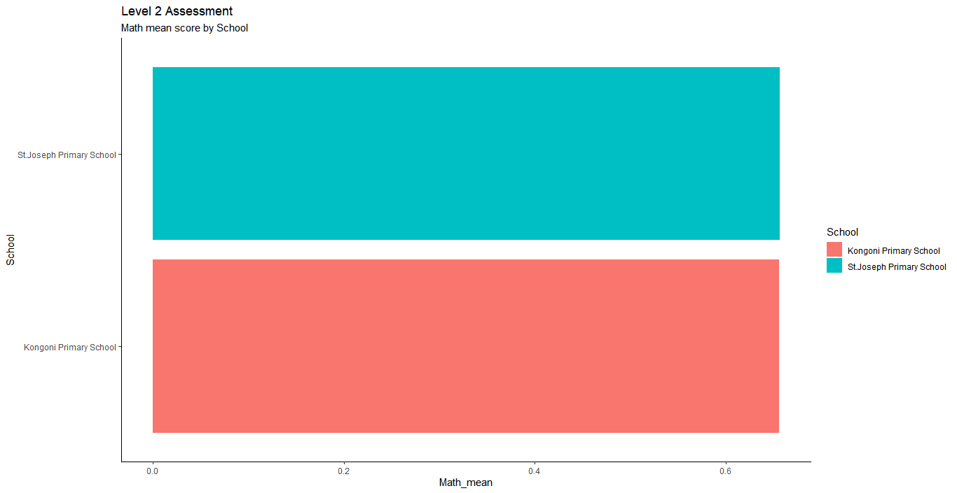

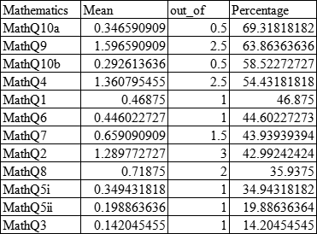

*Student performance on each mathematics questions. MathQ10a being highly performed and MathQ3 being the least performed.*

***Science performance***

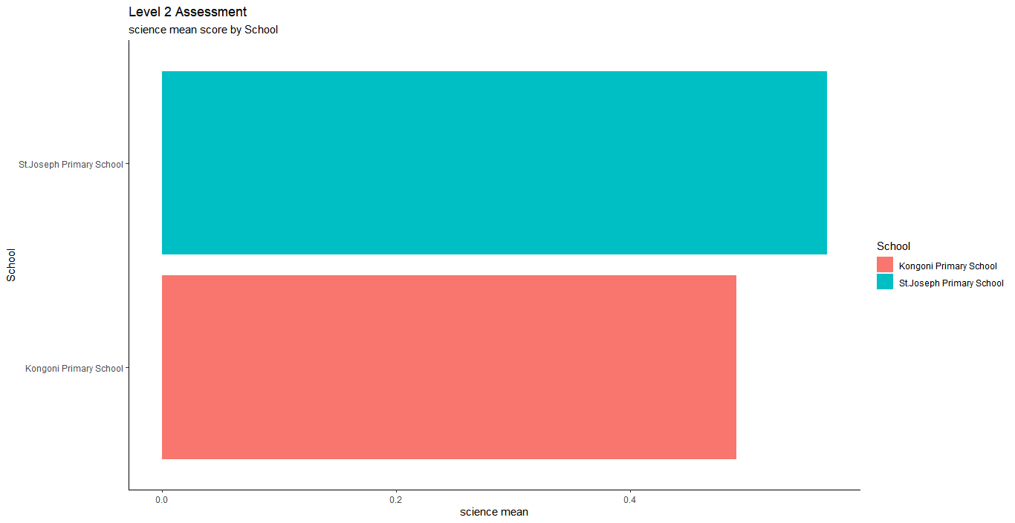 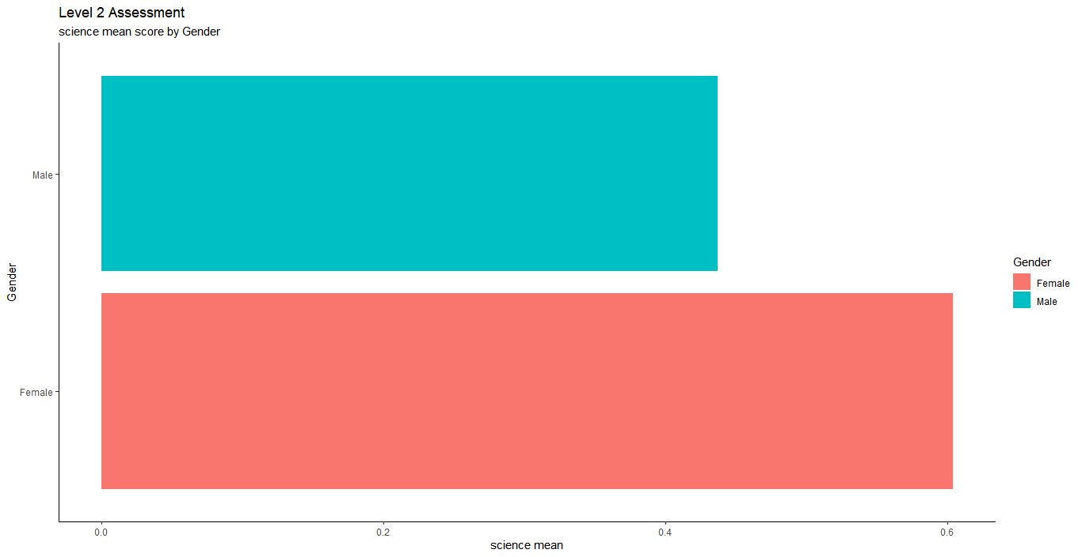

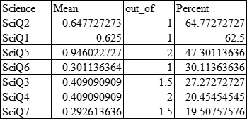

*Student performance on each Science questions. SciQ2 being highly performed and SciQ7 being the least performed.*

***Literacy performance***

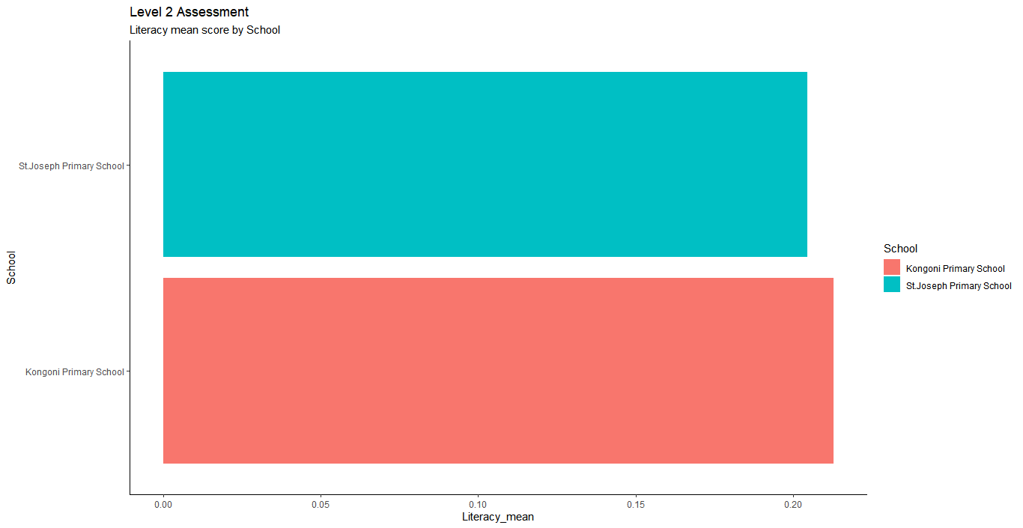 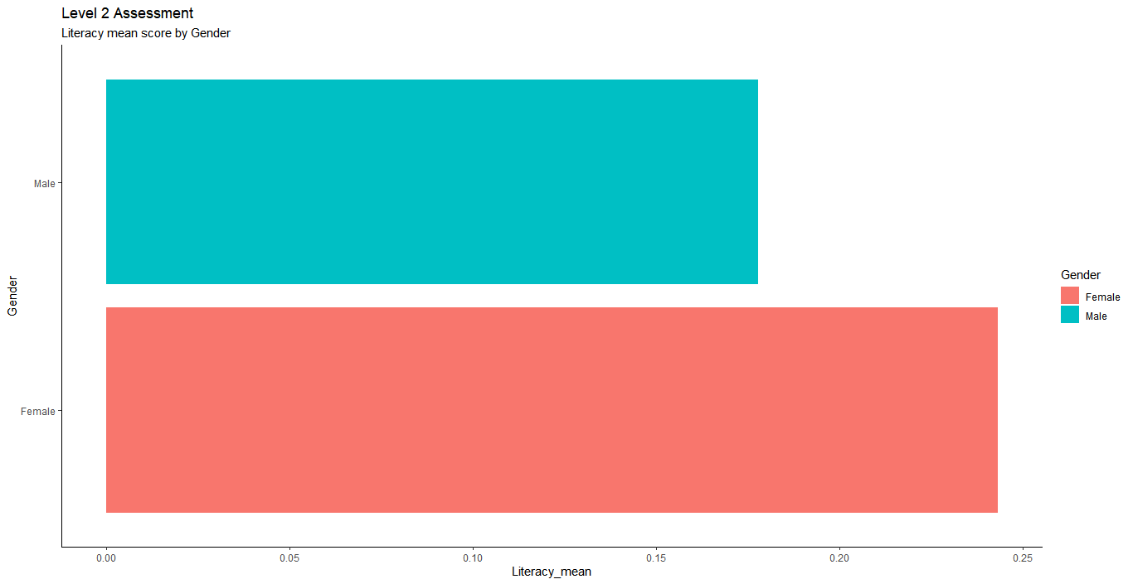

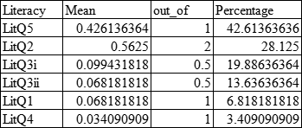

*Student performance on each Literacy questions. LitQ5 being highly performed and LitQ4 being the least performed.*

***Skill performance***

